**Final Report**

**Multi-Lingual College Enquiry ChatBot**

**Artificial Intelligence**

**(INT-404)**

By

|  |  |  |  |
| --- | --- | --- | --- |
| **Sr. No.** | **Registration No** | **Name of Students** | **Roll No** |
| 1 | 11801200 | Abhinay Kurapati | 37 |
| 2 | 11807484 | Shivam Tewari | 56 |

Lovely Professional University

Jalandhar, Punjab, India.



**ABSTRACT**

Our project, as can be told by it’s name, is a Chatbot; which refers to a computer program that is capable of doing conversations with human-like instincts (which may include a touch of feelings like excitement , sympathy etc.).

So, our project if put simply, ‘talks like a human’. Apart from that this project was made keeping in mind that the talking experience should be flawless, and entertaining since that would allow it to increase it’s understanding with the human user. And once, both the sides become comfortable with each other, it enhances the readability of the human user i.e. the primary mode of communication between the user and the program.

This project contains the ‘related work’ (i.e. the existing work analysis), it’s implementation, the result (i.e. the snapshots of output), various libraries used, each team-member’s responsibilities, and references (i.e. the source of our research).

**Related Work**

The goal of our chatbot ‘Sean’ is to solve any user doubts concerning the college (or, university) in which the user might be studying. This regards anything from the information about the college library to the information about lodging a complaint about any of the residential facilities present in each University opted by the student.

To access the program’s functionality, one just needs to execute it. For that, one has to follow the instructions in ReadMe file provided (namely, run.doc). But at execution, Sean will greet the user in a language of your own choice (i.e. either ‘English’, ‘Hindi’, or ‘Telugu’). Apart from that, he will also answer all the questions in the chosen language only. Currently, Sean is limited to 3 languages (English, Hindi and Telugu), but since the scope of this project depicts it’s usage in any generic college, so it might be updated in order to increase support for other languages.

**IMPLEMENTATION**

That’s pretty much about the functionality of the Chatbot. Let’s talk about what’s behind this project of ours. So, primarily our goal was to create a program which could handle both the backend (i.e. the barebone components for the program to work out in the most expected way) and the frontend (i.e. the GUI components that the user would be able to interact with). But since we were given the responsibility to make our chatbot to be multilingual in nature by our teacher, the G.U.I. part got on hold. Apart from that fact, this chatbot is working in the most expected manner.

So, the chatbot is prepared by the usage of ‘nltk’ (acronym for Natural Language Processing) library in python. And since this library supports the usage of regex (an acronym for REGular EXpression) which allowed us to add certain basic functionalities (like using the user-inputted data values). Moreover, this also allowed us to add tons of variations to the user’s inputs as well as to the program’s respective responses. The basic working of this library includes the formation of question-answer pairs. This enables it to match the user input at the runtime with the question string and return a random answer from the corresponding answer list.

For the other languages, we have implemented a *unilingual interface*, which means that only a single language is used by the interface between the user and the program. So, if user talks in ‘Hindi’, then the program shall also respond in ‘Hindi’ to the user.

And hence, the most obvious concept behind this is simply translating the questions in English along with mild to severe modifications (this is done to represent the similar kind of sense as is represented in English).

Apart from that one thing to be noted about this is that, we have imported the attribute ‘reflections’, so as to implement an automatic response to the personal pronouns (like ‘I’, ‘my’ / ’mine’) as the 2nd person pronouns (‘you’, ‘yours’).

**RESULT**

The following are some screenshots of the chatbot while in action: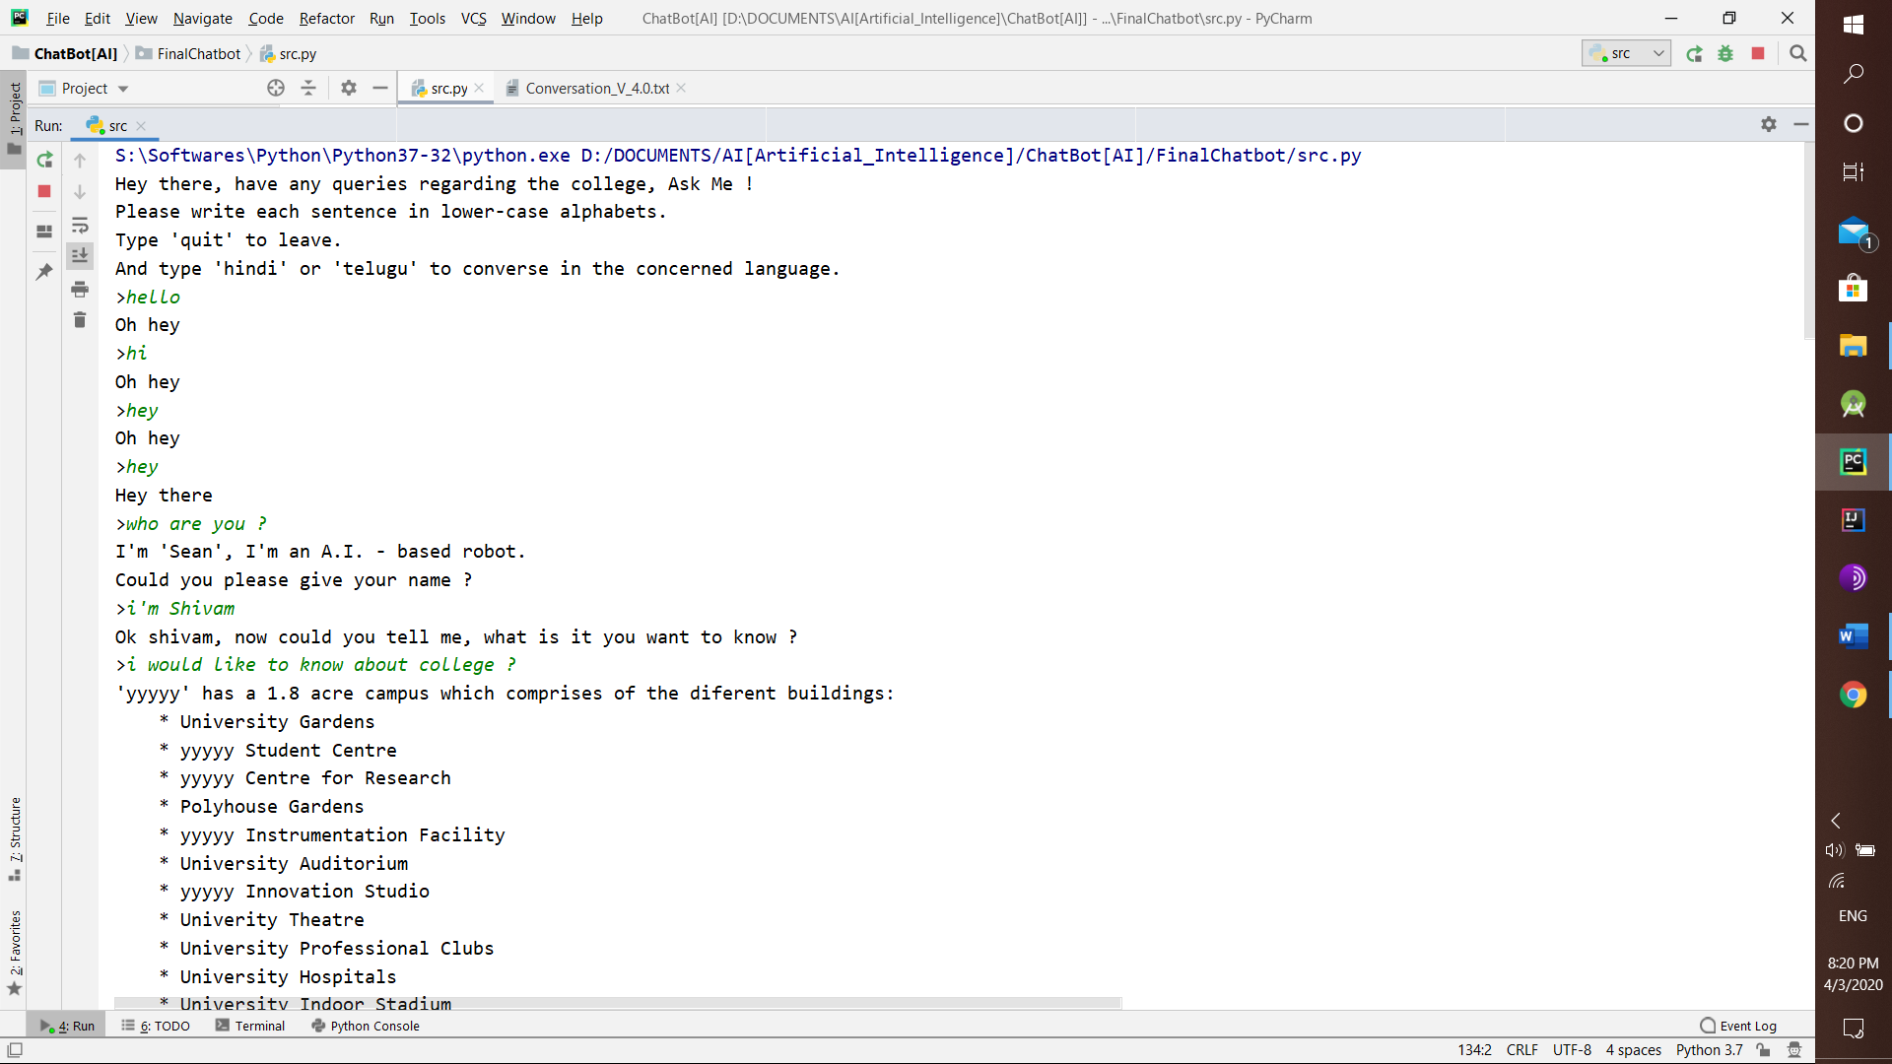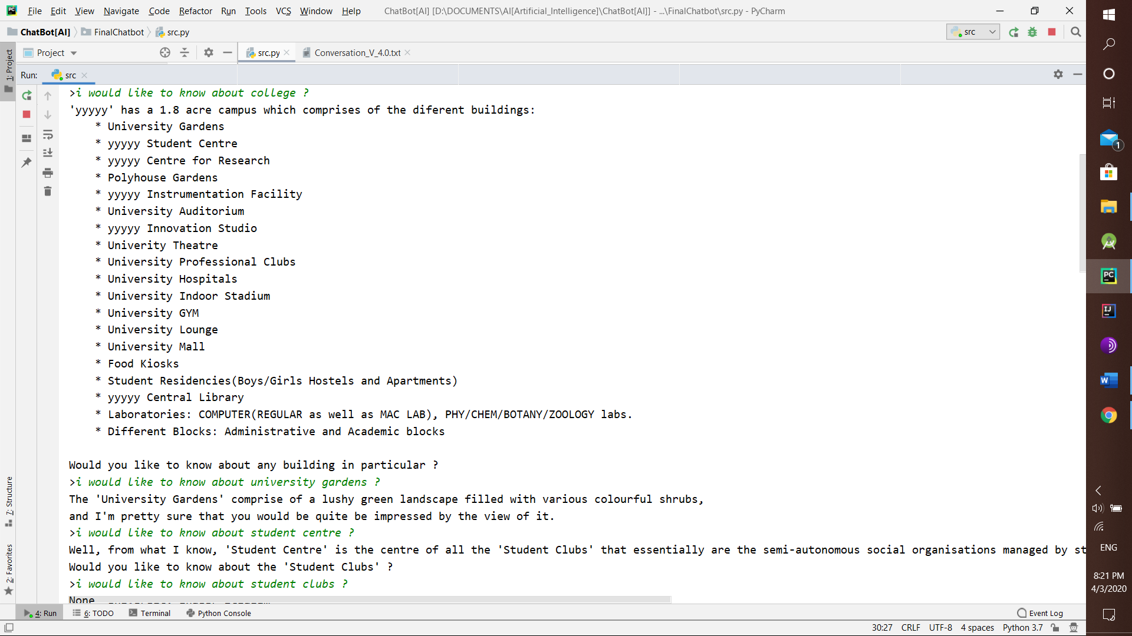

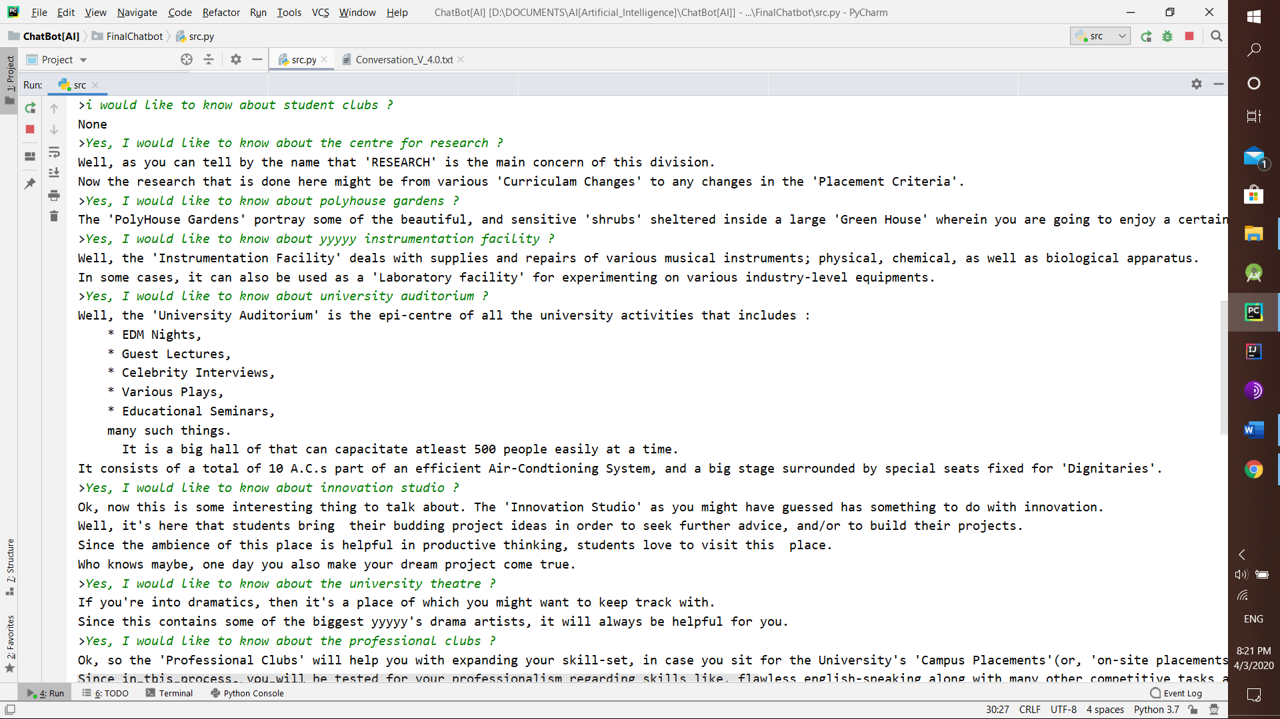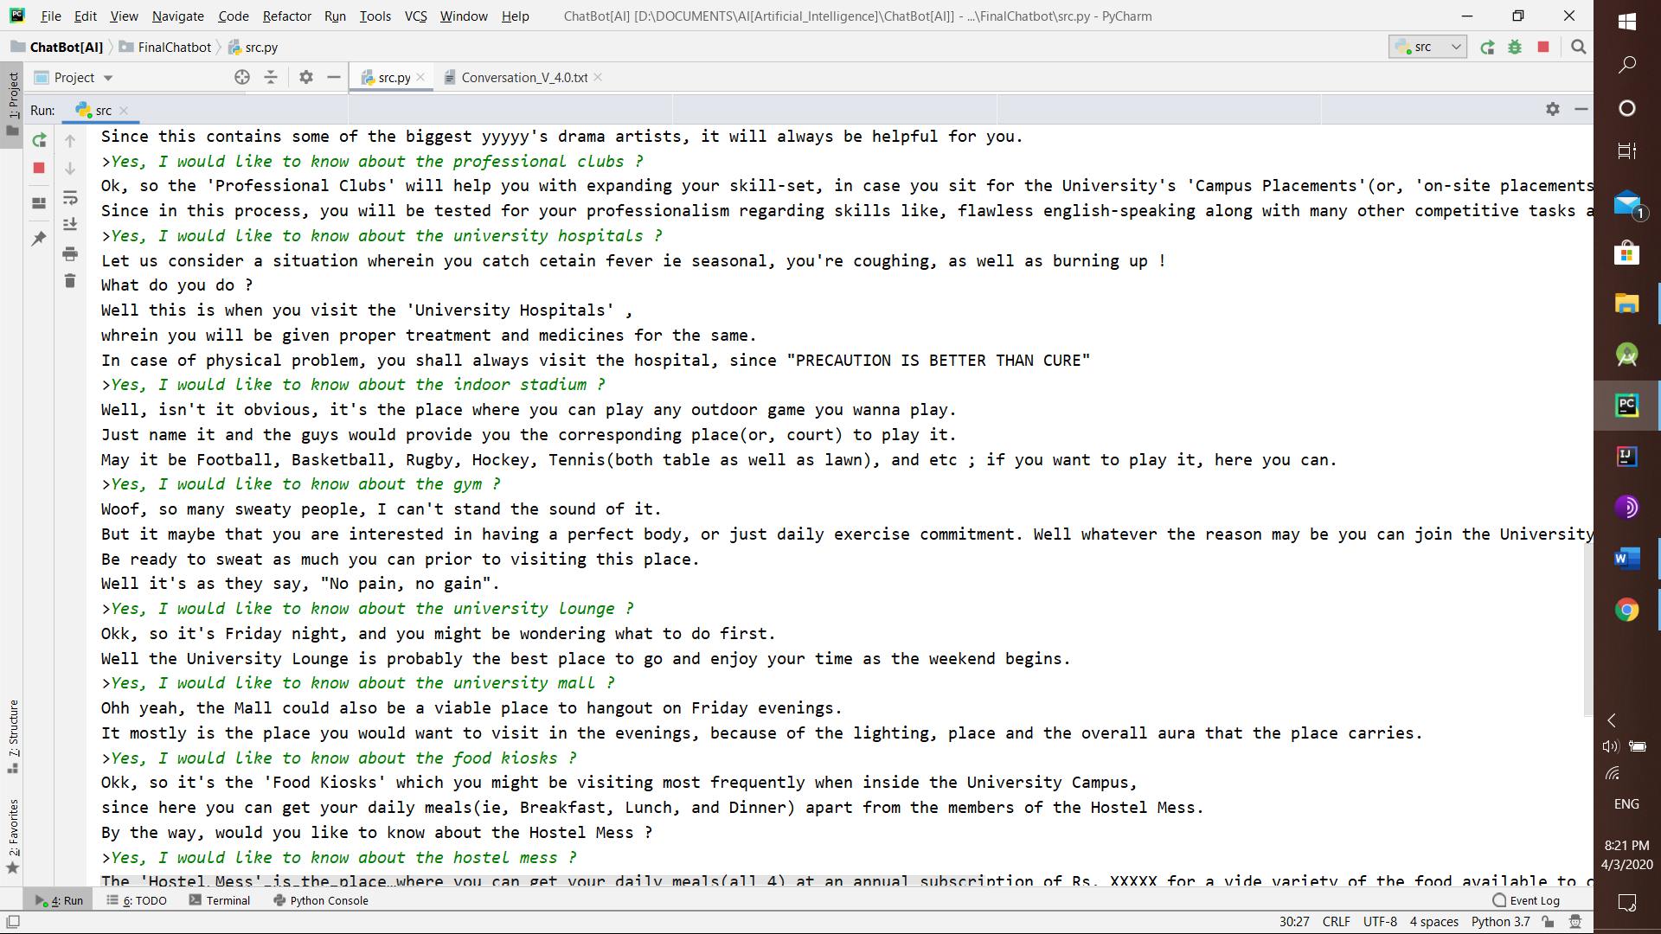

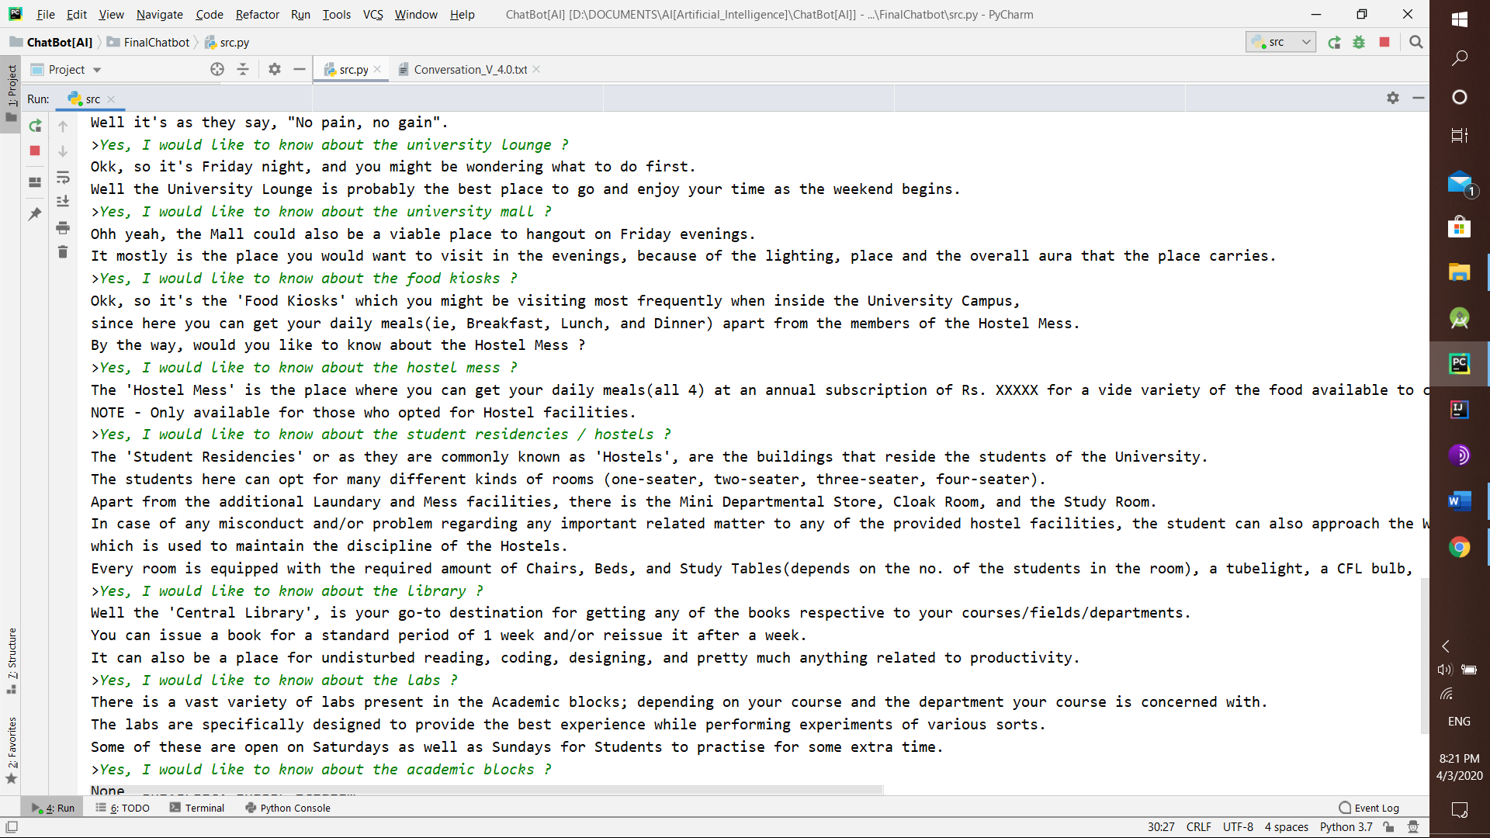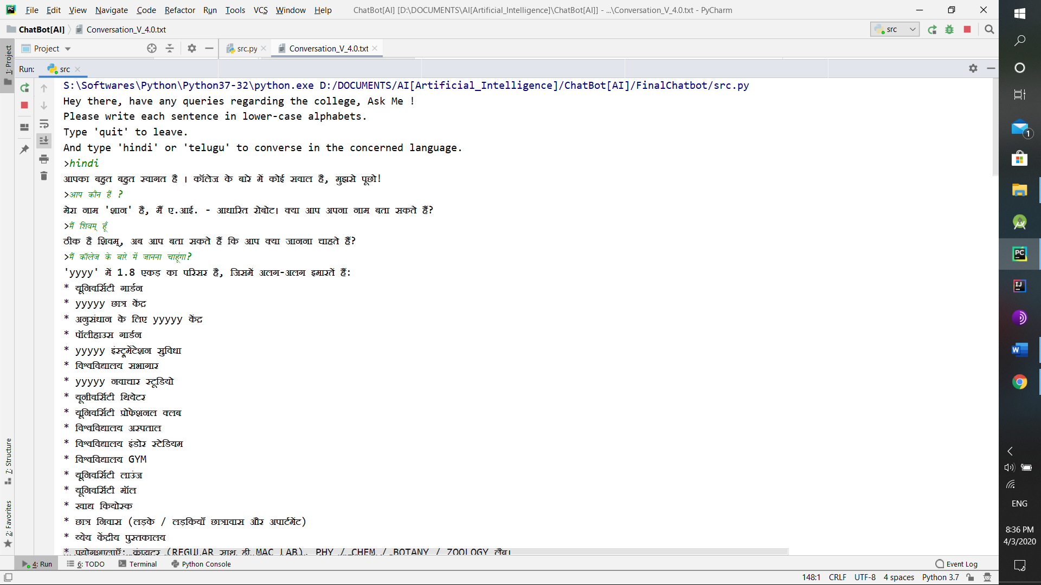

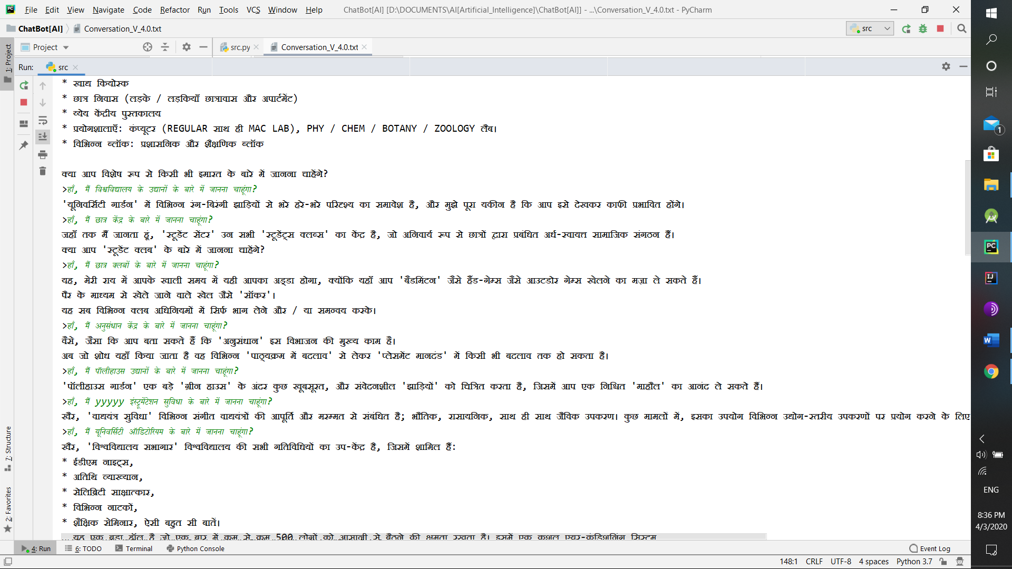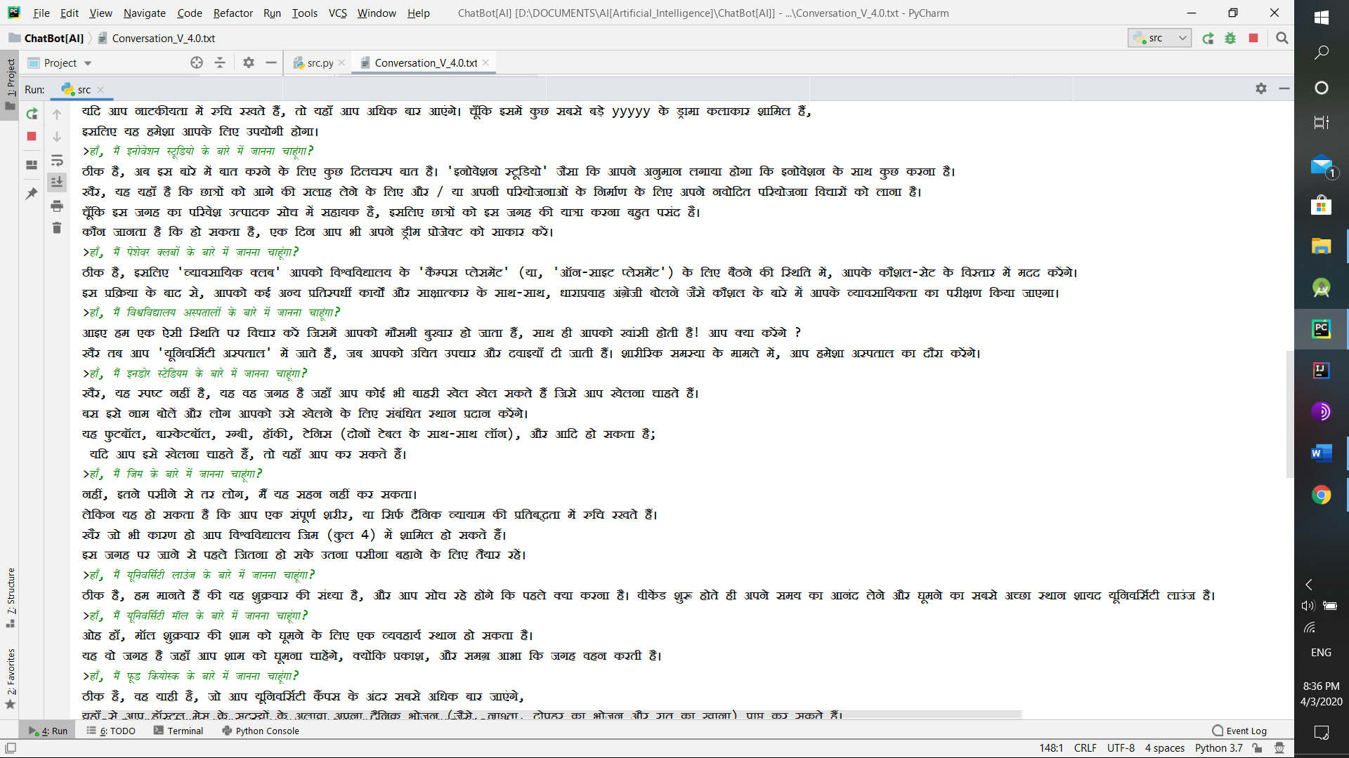

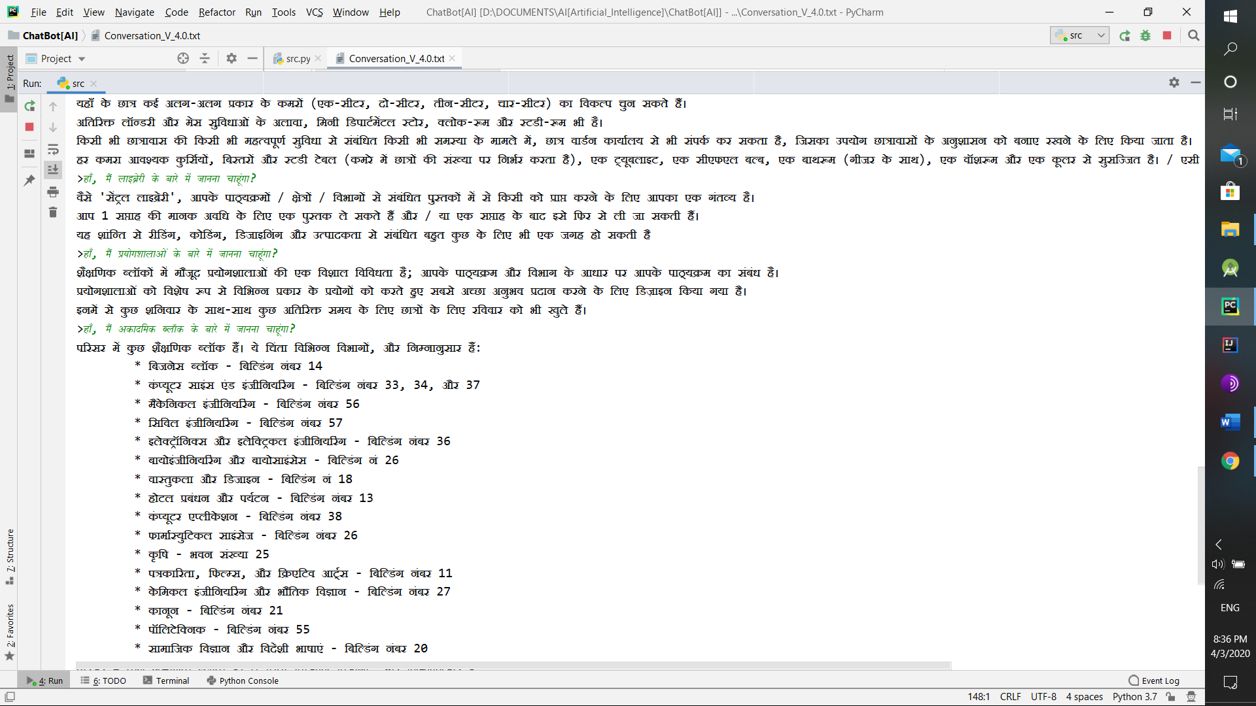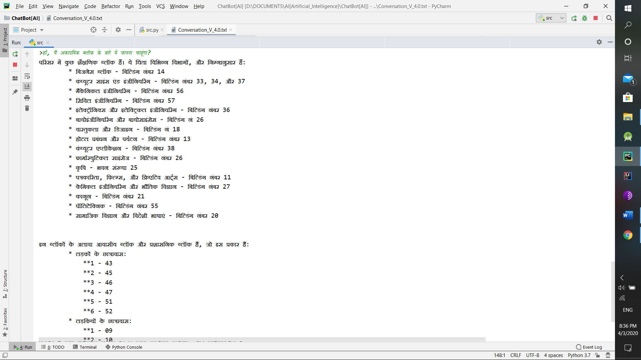

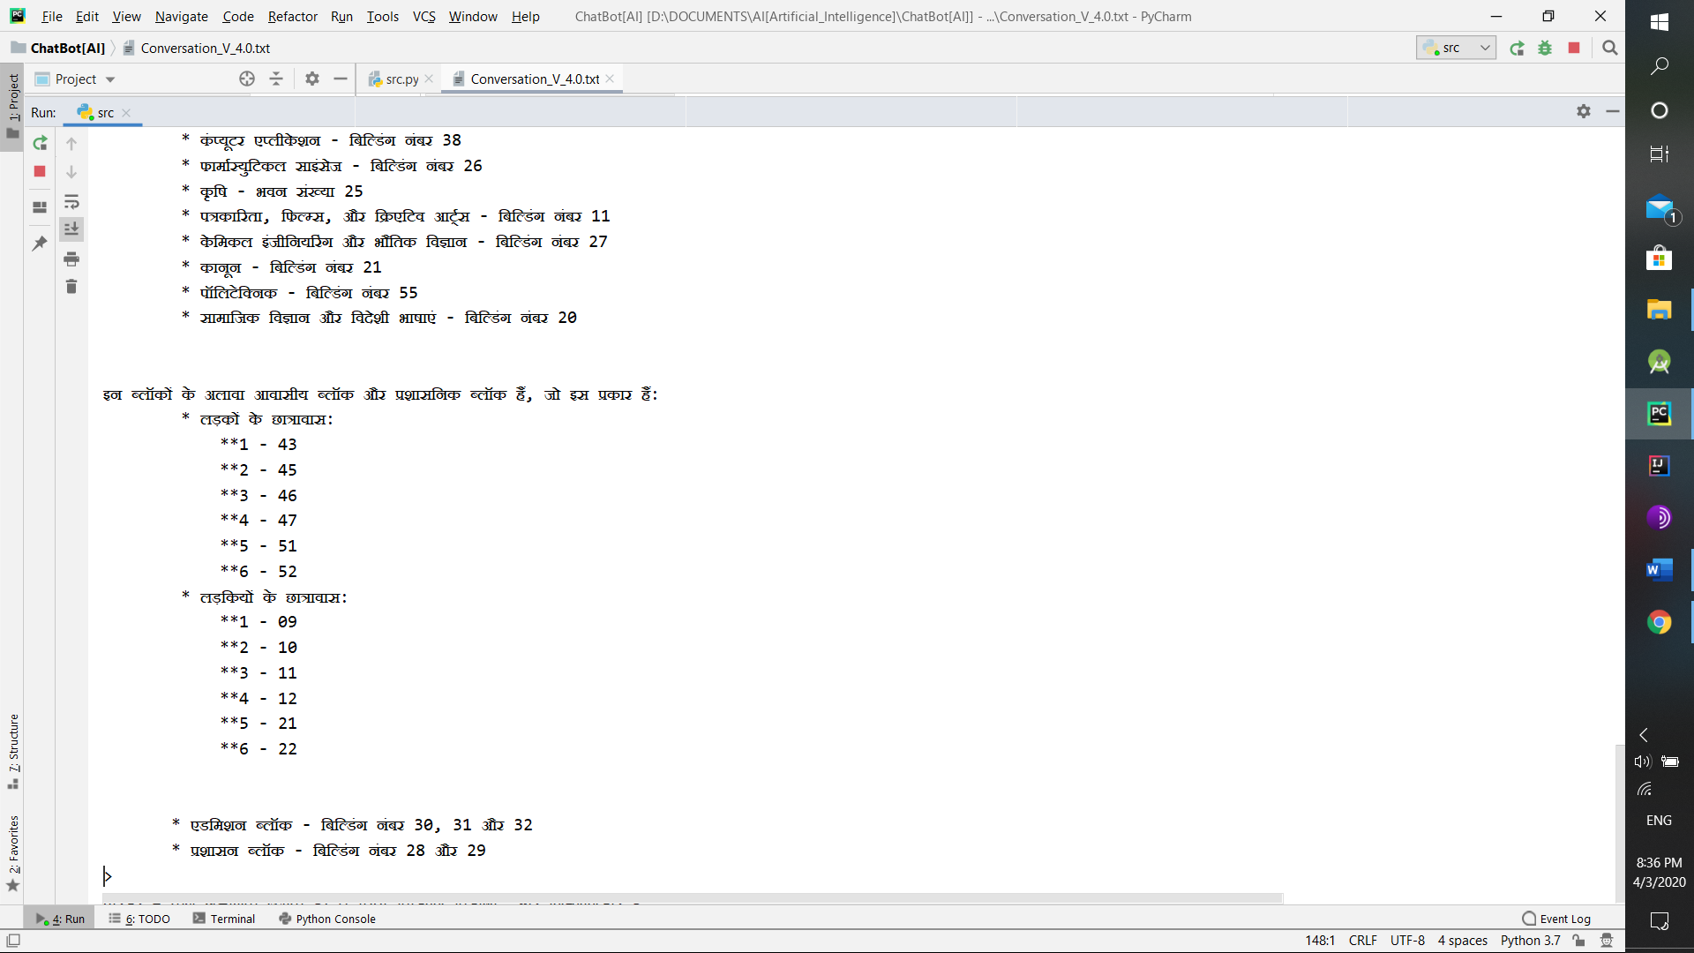

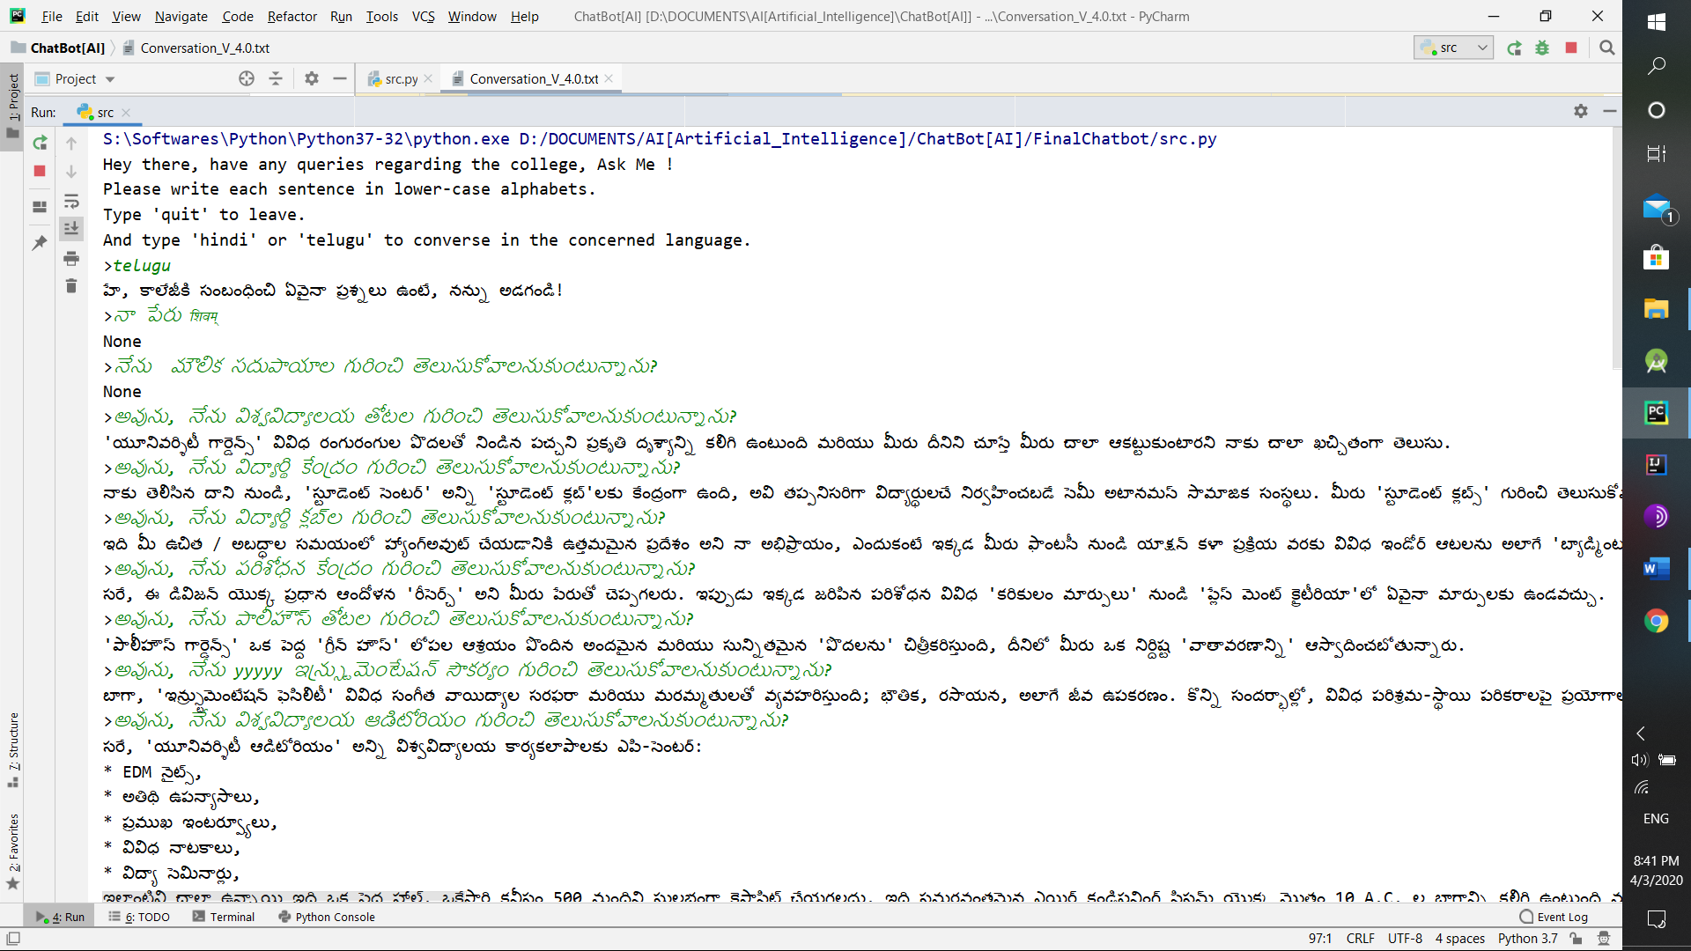

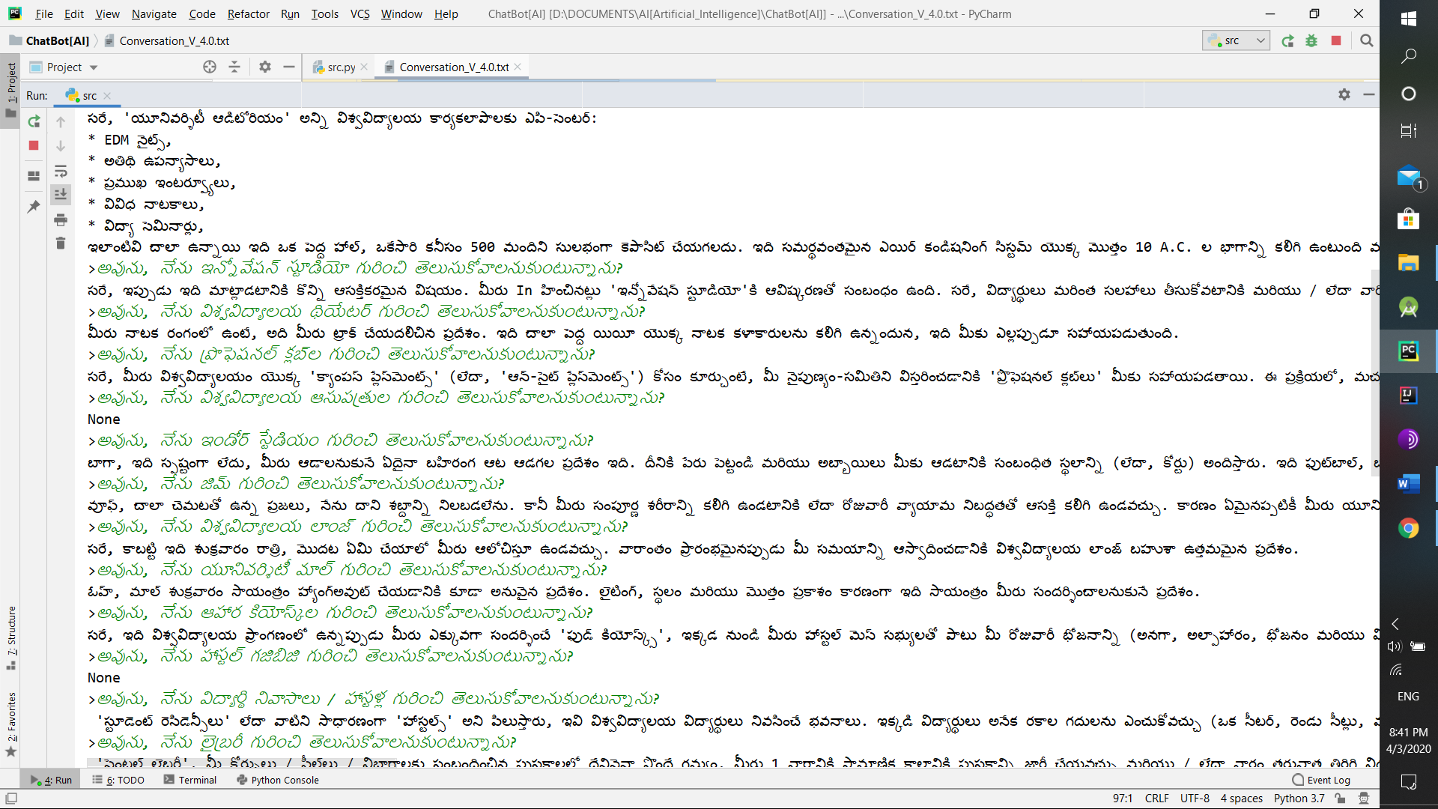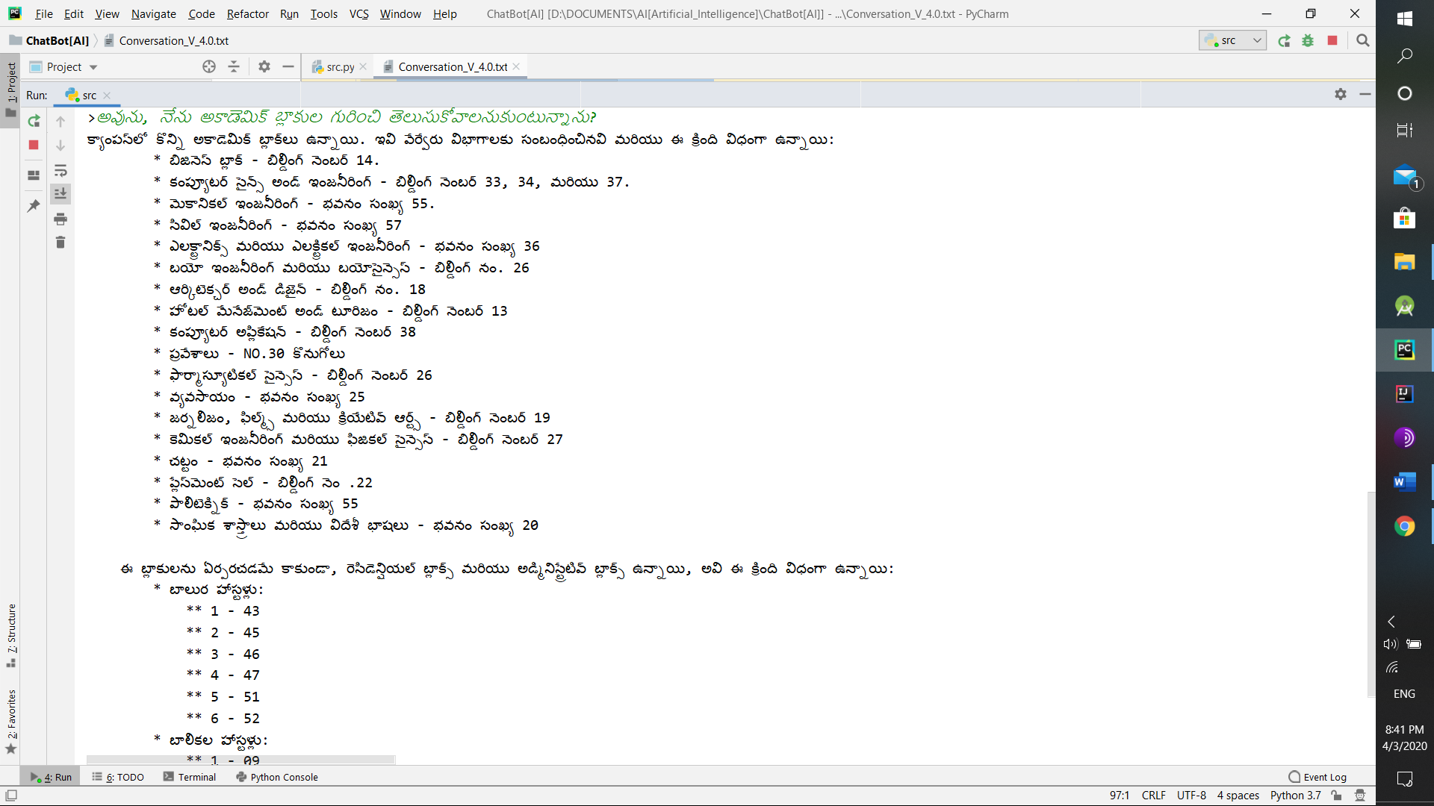

**Libraries Used:** nltk (Chat class and reflections attribute) – a python library abbreviated for Natural Language ToolKit.

**Team Responsibilities:** So, for this project, each team-member had the following responsibilities:

* Shivam (11807484) –
  + Integration of Natural Language (English) both in ‘Converstions.txt’ as well as in the ‘src.py’ file.
  + Integration of Natural Language (Hindi) in ‘src.py’ file.
  + Creation and Maintaining of Github Repository. Link - <https://github.com/ShiviPro/College-Enquiry-ChatBot> .
  + Testing the code against various inputs.
* Abhinay (11801200)-
  + Integration of Natural language (Telugu) both in ‘Conversation.txt’ file as well as in ‘src.py’ file.
  + Integration of Natural Language (Hindi) in ‘Conversations.txt’.
  + Maintaining of the Github repository.
  + Refactoring the code for reformatting as well as for efficient code usage.

**References:**

* <https://nevonprojects.com/college-enquiry-chat-bot/> for reference about project.
* <https://www.geeksforgeeks.org/tokenize-text-using-nltk-python/>
* <https://www.nltk.org/>

Both are used for NLTK library’s reference matter.